Project Demonstration Phase
Project Demonstration Link & Walkthrough Script
Date | 14 October 2026
Team ID
Project Name | Automated Network Request Management System
Maximum Marks | 4 Marks

Project Deliverable Links & Repository Access:
Resource Name | URL / Access Path | Description & Credentials
Demonstration Video (Google Drive) | https://drive.google.com/file/d/1BnriywWde1DKvn6q077Kuw0jLV53ShrK/view?usp=drivesdk | Full 13-minute video (2560x1440 HD, 446 MB) recorded by Pooja Reddy showing live instance walkthrough.
GitHub Project Repository | https://github.com/poojareddy24817/automated-network-request-management-servicenow | Complete source repository containing project architecture, functional scope, execution roadmaps, and all phase templates.
ServiceNow Instance | https://dev251577.service-now.com | Personal Developer Instance hosting catalog item 'Network Request1', flow, custom table 'Database Table1', and portal.
Video Walkthrough Timeline & Stage-by-Stage Verification:
Video Timestamp | Demonstration Topic | Live Technical Features Shown
00:00 - 01:15 | Custom Table Schema (Database Table1) | Navigates to sys_db_object; opens 'Database Table1' (u_database_table1); verifies column definitions: Mode of Payment, Requested For, Approval Status, Customer Address, Total Amount, Mobile Number, Database Number.
01:16 - 02:05 | System Relationship Definition | Opens sys_relationship record 'Approval request1'; reviews script linking u_database_table1 to sysapproval_approver with source_table and parent.sys_id.
02:06 - 04:10 | Service Catalog Configuration | Navigates to sc_cat_item; opens 'Network Request1'; inspects 7 variables: Requested for (order 100), Mobile Number (order 200), Type of Connection (order 300), Existing ID (400), Total Amount (500), Mode of Payment (600), Address (700).
04:11 - 04:35 | Catalog UI Policy Logic | Opens Catalog UI Policy 'visible/hide of ID field'; confirms conditions: when Type of Connection is 'Existing', dynamically display and require 'Existing ID'; reverse if false.
04:36 - 07:10 | Workflow Studio / Flow Designer | Opens Flow Designer flow 'Network Request1'; reviews trigger (Service Catalog), Action 1 (Get Catalog Variables), Action 2 (Create Database Table1 Record mapping data pills), Action 3 (Send Email), Action 4 (Ask for Approval).
07:11 - 09:10 | Flow Branching & Fulfillment Task | Inspects 'If Request is approved' branch; reviews Action 6 (Update Record: sets Approval Status to 'Approved', assigns to 'ITIL User'); reviews Catalog Task generation for network fulfillment.
09:11 - 10:20 | Flow Execution Runtime Logs | Opens sys_flow_context execution details; shows successful execution of Get Catalog Variables (36ms), Create Record (18ms), Send Email (46ms), and Waiting state on Ask for Approval (278ms).
10:21 - 11:35 | Live Service Portal Order Submission | Navigates to dev251577.service-now.com/sp; searches 'Network Request1'; fills form as Abraham Lincoln (Phone: 555-555-0004, Connection: New, Amount: 2345, Payment: UPI, Address entered); clicks 'Order Now'; generates REQ0010005 & RITM0010005.
11:36 - 12:59 | Approvals, Email Logs & Tasks | Reviews approval record on sysapproval_approver; opens sys_email previews ('Request REQ0010005 was created' and 'was approved'); inspects Tasks list showing SCTASK ready for engineering provisioning; confirms SkillWallet story completion.

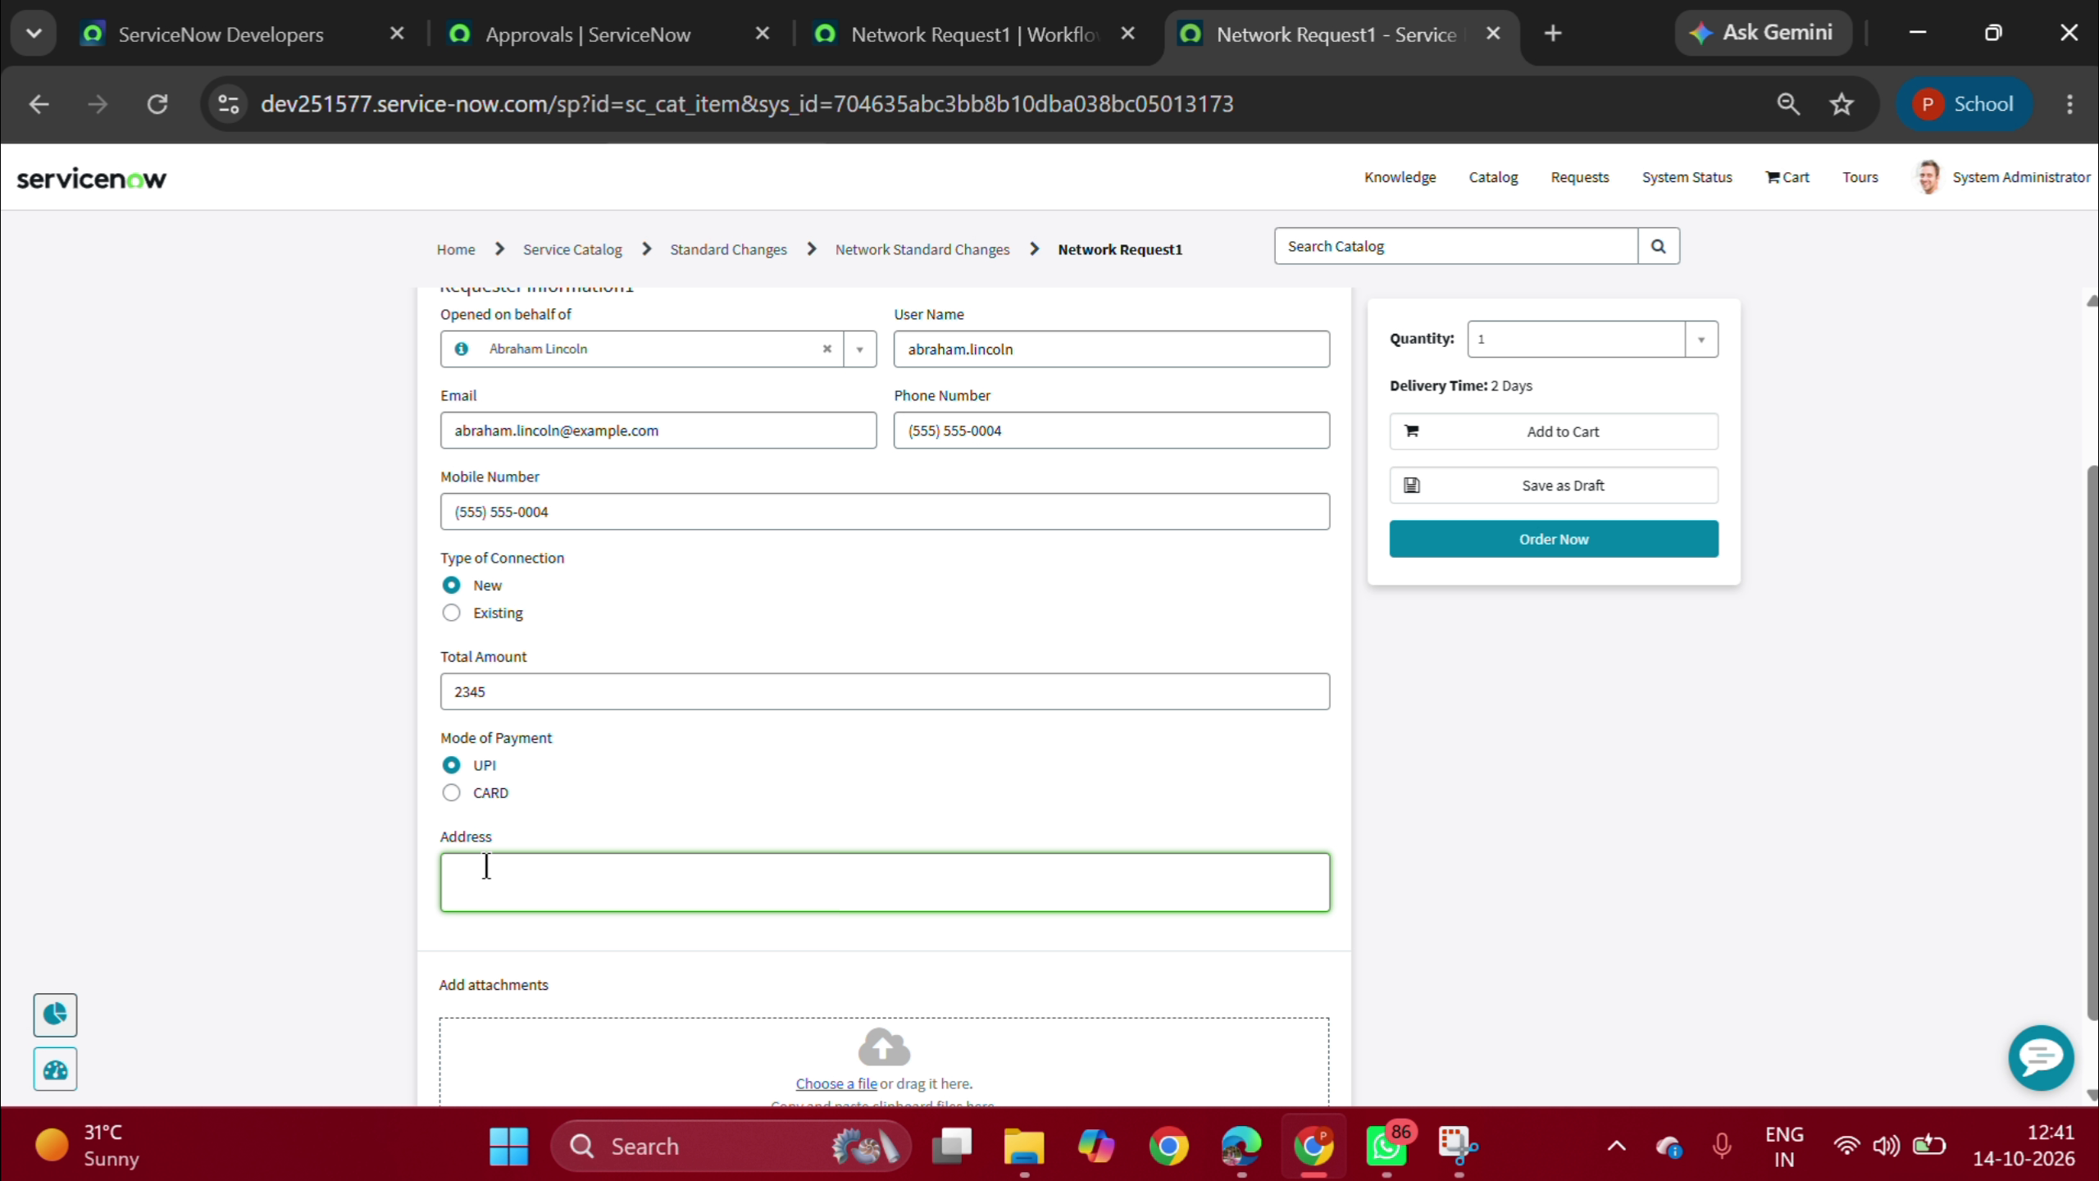
Figure 7.1: Live Service Portal Form Submitted during Video Demonstration (REQ0010005)

